Corpus-Based Dictionary

What is Corpus-Based Dictionary
# Source: AI Source: Provided by: [Data Path: Persons Table -> ID Column: 1, Name_En Column: Motasem Essam] -> From: [Chatgpt (GPT-4-turbo)] on [7/30/2025]
A Corpus-Based Dictionary is a dictionary created using data from a language corpus—a large, structured collection of real-life language use (spoken or written). These dictionaries reflect how language is actually used, not just how it should be used, making them especially valuable for learners, linguists, and educators.

✅ Key Features:
# Source: AI Source: Provided by: [Data Path: Persons Table -> ID Column: 1, Name_En Column: Motasem Essam] -> From: [Chatgpt (GPT-4-turbo)] on [7/30/2025]
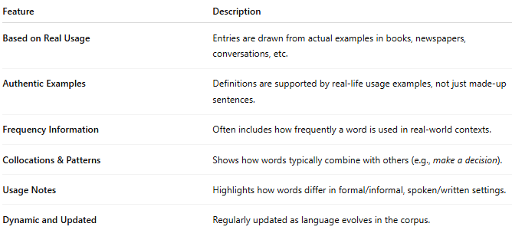

Feature | Description
Based on Real Usage | Entries are drawn from actual examples in books, newspapers, conversations, etc.
Authentic Examples | Definitions are supported by real-life usage examples, not just made-up sentences.
Frequency Information | Often includes how frequently a word is used in real-world contexts.
Collocations & Patterns | Shows how words typically combine with others (e.g., make a decision).
Usage Notes | Highlights how words differ in formal/informal, spoken/written settings.
Dynamic and Updated | Regularly updated as language evolves in the corpus.

👤 Primary Users:
# Source: AI Source: Provided by: [Data Path: Persons Table -> ID Column: 1, Name_En Column: Motasem Essam] -> From: [Chatgpt (GPT-4-turbo)] on [7/30/2025]
- Language learners (especially intermediate/advanced)
- Linguists and language researchers
- ESL/EFL teachers and students
- Writers and translators
- Lexicographers

📘 Examples of Corpus-Based Dictionaries:
# Source: AI Source: Provided by: [Data Path: Persons Table -> ID Column: 1, Name_En Column: Motasem Essam] -> From: [Chatgpt (GPT-4-turbo)] on [7/30/2025]
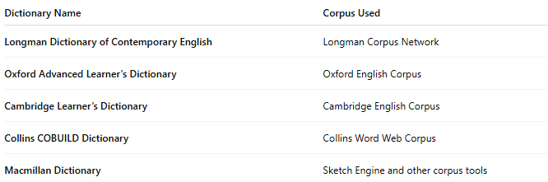
Dictionary Name | Corpus Used
Longman Dictionary of Contemporary English | Longman Corpus Network
Oxford Advanced Learner’s Dictionary | Oxford English Corpus
Cambridge Learner’s Dictionary | Cambridge English Corpus
Collins COBUILD Dictionary | Collins Word Web Corpus
Macmillan Dictionary | Sketch Engine and other corpus tools

🟢 Benefits:
# Source: AI Source: Provided by: [Data Path: Persons Table -> ID Column: 1, Name_En Column: Motasem Essam] -> From: [Chatgpt (GPT-4-turbo)] on [7/30/2025]
- Reflects modern, natural language use
- Provides realistic examples and collocations
- Useful for learning context, tone, and frequency

🔴 Limitations:
# Source: AI Source: Provided by: [Data Path: Persons Table -> ID Column: 1, Name_En Column: Motasem Essam] -> From: [Chatgpt (GPT-4-turbo)] on [7/30/2025]
- May contain informal or region-specific examples that require explanation
- Can be complex for beginner users
- Focus is more on usage than etymology or pronunciation

